SCCC Minutes 7.16.19 DRAFT

Snowmass Capitol Creek Caucus Board Meeting July 16, 2019
Snowmass Fire Station Annex

CALL TO ORDER
Board members present: David Chase, Chris Collins, Michael Kinsley, Jill Sabella, Vicki Treece, Molly Child, Glenn Russell
Guests: Laurie and John McBride, Alice Collins, Mark Grotjahn, Marcia and Tony Fusaro, Nancy and Dwight Maurin, Meredith and Aaron Oakley
Presenters: Suzanne Stephens, Executive Director of Aspen Valley Land Trust, and Erin Quinn, Conservation Director of Aspen Valley Land Trust (avlt.org)

APPROVAL OF MINUTES
A motion to accept the May minutes was made by David Chase, subject to final review by email.
All approved.

TREASURER’S REPORT
Vicki presented both May and June financial statements.
May’s balance was $45,170.00, with $20,189.49 unrestricted and $24,980.51 in the restricted Snowmass water work fund.
June’s balance was $45,150.00 with $20,169.49 unrestricted and $24,980.51 in the restricted Snowmass water work fund.
There were only incidental expenses for both months.

COMMITTEE REPORTS

Land Use
Suzanne Stephens and Erin Quinn made a presentation on Conservation Easements in Capitol Creek Valley - those easements that already exist and the philosophy of the Aspen Valley Land Trust. The most recent AVLT conservation easement is the Lost Marbles Ranch, 1870 acres given by the McBride family, chiefly on the west side with additional on the south side of their property up Capitol Creek Valley. There is no public access on this easement. The Capitol Creek Ranch and Windstar easements (both co-held by AVLT and Pitkin County) provide public access along designated routes only. Other conserved ranches in the area (without public access are Harvey Ranch, part of the Weiben Ranch, and Watson Divide. The Capitol Creek Ranch easement was formerly owned by the Child family and is currently owned by Mark Grotjahn and Steve and Molly Child as two parcels. Access easements can be permanent if they are part of a conservation easement, or re-negotiable if they are not part of a conservation easement and separately granted. It depends of the terms of the easement.
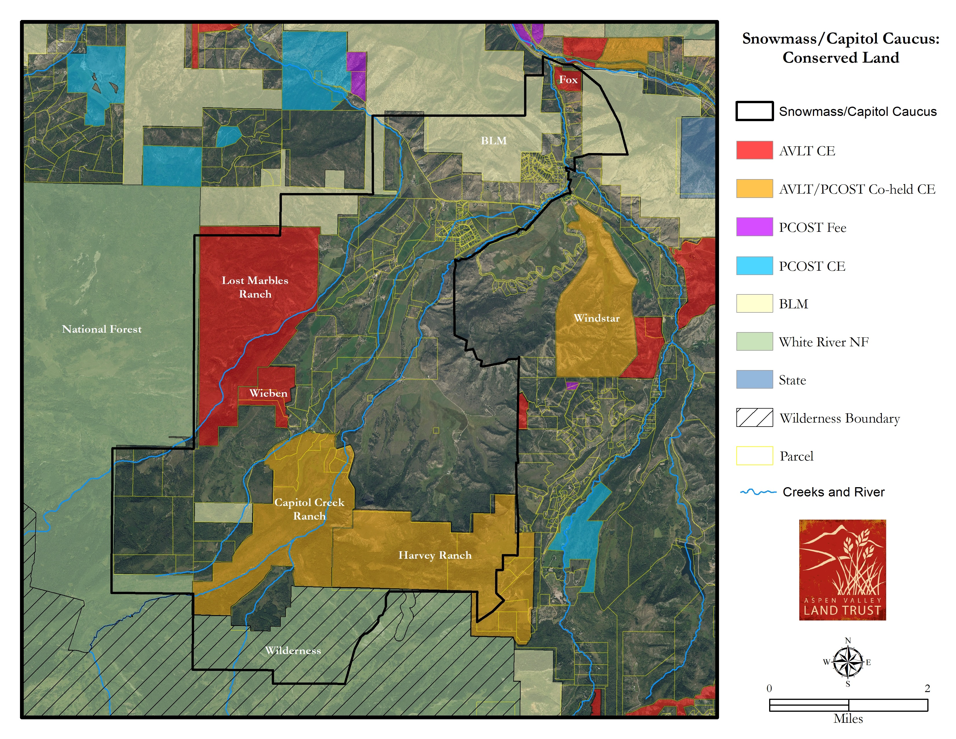
AVLT is a non-profit organization where as the County’s OST is funded by tax payer dollars but this does not necessarily mean open access.

The presentation looked at the scope of easements - setting aside land for longterm conservation, what has been preserved and what may come to pass, and what guides some of the decisions. AVLT covers land easements from Independence Pass down to the Roan Plateau, which includes five counties.

Erin addressed the threats to open land and why conservation is imperative, such as rapid population growth in the area, development pressures such as roads and commercial shopping areas and diminishing water resources. She stressed how land conservation protects one’s way of life, with considerations like rivers and streams, public spaces, wild places for deer and elk habitat, recreation and environmental education, historic sites (like the Redstone coke ovens), learning experiences, iconic working landscapes, life-giving water, local food production, and hard-earned heritage.

There are variety of arrangements that can be made, all voluntary.
One can conserve land while maintaining ownership. The land can’t be developed, but the transfer helps with taxes.
The land can be bought, sold or mortgaged.
It’s a tool to help protect a way of life, and it’s forever in that the easement runs with the title of the land, not with the owner.

AVLT’s long range plan through conservation easements is to knit together corridors, especially down to the river.
Erin and Suzanne went briefly over the process - the appraisal and the credits and deductions allowable in transferring land into a conservation easement.

Annual Caucus Picnic
General discussion about putting up road notices in key locations, Caucus Board food contributions, McCabe Ranch contributions, Capitol Creek Brewery contribution. Final arrangements will be made by email before the picnic on August 10th.

David moved to adjourn the meeting. Michael seconded. All in favor.

